**Shri Ramdeobaba College of Engineering and Management, Nagpur**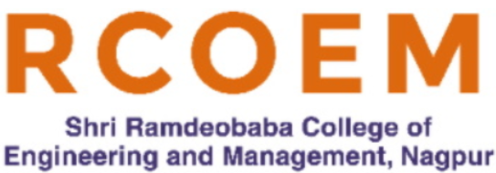

***Department of Information Technology***

***Sem-VI***

***Synopsis***

***on***

**NFT MarketPlace - ApnaMarket.NFT**

.

**Group Members**

1. Atharva Baheti (28)

2. Harsh Singh (34)

**Under the guidance of**

**Dr. P. D. Adane Viresh Dhawan**

HOD IT Department Data Scientist, ZS Associates

Blockchain Specialist IndustryMentor

**Information Technology Department**

**7**

# Introduction

## Overview

NFT or "Non-Fungible Token" is a non-fungible asset that is unique and cannot be split. NFT can be connected to real-world objects. NFT can have only one official owner in the world as it is stored and secured using Blockchain technology, which means no one can modify the ownership of an NFT which exists. The ownership can be sold to another person and only then it will be reflected on Blockchain.

WEB3.0 ApnaMarket.NFT Platform works on Blockchain Technology. It provides artists a solution to earn money on an early basis and helps one to invest their money in songs and get equity in terms of streaming royalties. Artists will have to distribute their songs on all the streaming platforms through our application.

WEB3.0 ApnaMarket.NFT Platform will be a value system. Any purchase on Art NFT, then betting that the artist's value will rise in the future which will lead to increase in streams and revenue generation from the part of equity held by the trader.

# Functionalities

* Sell partial/complete ownership of the song/Art.
* Share royalty income.
* Connect fan community and personal interaction.
* Buy and sell merch/tickets.
* Stream Music
* Create playlists

Following are the objectives that ApnaMarket.NFT aims to achieve:

* Ease out the process of researching the NFT market.
* Provide a platform for robust NFT trade.
* Be a one stop destination for novice traders to trade NFTs .

# Hardware/Software Requirements

* **Polygon** Framework: Polygon is a decentralized Ethereum scaling platform that enables developers to build scalable user-friendly dApps with low transaction fees without ever sacrificing on security.
* **Hardhat** : It is a Solidity development environment for our DApp.
* **Solidity**: It is used for writing smart contracts for NFTs.
* **Metamask**: It is a software cryptocurrency wallet that helps us interact with the Ethereum blockchain and make transactions.
* **Next.js and Tailwind CSS:** For Frontend part.
* **IPFS:** For file uploads and downloads.
* **Ethers.js**: For interaction with Smart Contracts.
* **ERC721:** Smart Contracts standard.

**Existing Platform**

**FanTiger Music NFT Marketplace:** FanTiger has a vast audience to trade NFTs and has reached around more than 50,000 transactions. FanTiger Works for 5 periods of time only whereas we will keep it for x period of time which depends upon the artist depends upon the artist choice for listing [period . Fantiger works on INR/USD holding with polygon Blockchain whereas we will have. Direct crypto process as we can see it is more universally accepted. Fantiger Credits one song as l'antiger Music NFT on the other hand here artists will have the feature of creating their own collection to name it.

____________________

Dr. P. D. Adane

( Project Guide )